Trigger-based switching controller

Owen Lu

Electroimpact Inc.

owenl@electroimpact.com

*Abstract*—Slight refinements control structure allowed for the reduction of peak torque requirements of the motor. However, using a single effective gain in the system creates inefficiencies by using more torque than is necessary for many scenarios. This controller which switches between two linear controllers allows two effective gains to be present in the system, allowing more dancer stroke and less stress on the motor.

# Introduction

The problem that this control structure aims to remedy is first and foremost the issue of the film material not being wrapped properly and causing failures due to tangling.

The failure has been observed to occur under the condition that most of the material on the spool has been run. After video review, the mechanism by which the failure occurs has been assumed below.

1. Material is run through the system, eventually significantly increasing the inertia of the film spindle
2. The large increase in rotational inertia exceeds the torque able to be provided via friction.
3. Slipping occurs between the carbon and film material, allowing the film spindle to spin at unsynchronized surface speed to the material spindle
4. Slack is formed since the film material spins slower than the material spindle.

Assuming this process of failure there are numerous ways to reduce and remove this failure entirely:

1. Increase tension
   1. Larger tension increases the friction linearly eventually allowing the film spindle to spin without slipping
2. Reduce maximum material spindle acceleration
   1. If this acceleration is smoothed out, the maximum acceleration that the film material must undergo is also reduced
3. Reduce inertia of the film spindle

All three can be implemented simultaneously, however, it is important to note the drawbacks. They are listed below:

1. Higher tension to some extent can be accepted but has also been thought to cause many other issues downstream of the creel inside the business end. Thus, an increase of this tension should be limited.
2. Maximum acceleration of the material spindle is specified by a gain constant. Reducing gain will necessarily increase dancer stroke, and subsequently overall tension. It also reduces the maximum speed of safe operation below the target specification.
3. Reduction of the inertia of the film spindle technically has no drawbacks although its effects are hypothesized to be small unless large design changes are made. The problem is that injection molds are used for the current design allowing very cost-effective manufacturing. The redesign would likely incur large initial costs or simply larger variable costs in the presence of uncertain performance gains.

# Velocity profile assumption

It has been discussed that the machine is assumed to have a payout velocity that has an initial step input to 2000in/min. Although in reality, this is not possible, it is a good model of the process so that the gain can be tuned.

Note that as mentioned before, it is in this rapid acceleration that the film material tends to lose tension. Lowering the steady-state gain has two functions in this case. More dancer stroke is used, creating higher tension. Simultaneously, lower initial acceleration is used, minimizing the amount of torque that needs to be transmitted to the film spindle.

At this point, the only problem with lowering the gain is that at higher speeds, the gain must be increased in order to eliminate dancer over travel. This creates the motivation for the switching controller system.

# Modified control structure

In essence, the new control structure modifies the existing one by adding an additional feedback path after the dancer displacement reaches a threshold value. This effectively doubles the steady state gain for higher speeds if the threshold is set correctly.

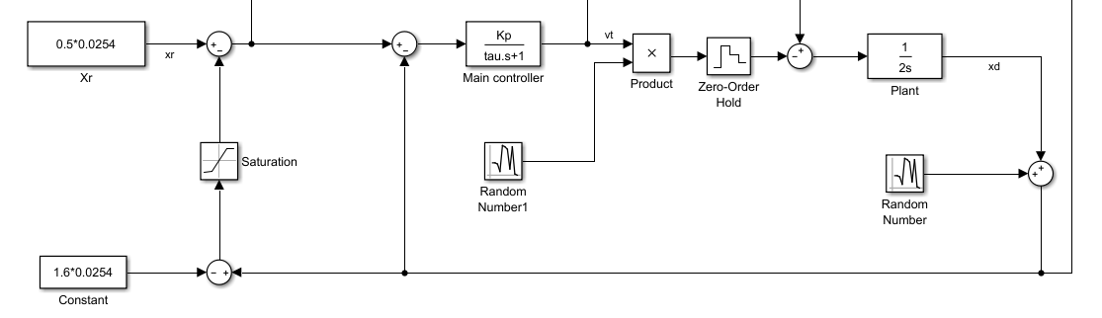

Figure 1 - Switching controller structure

The steady-state displacement is written in Eq. 1.

|  |  |  |
| --- | --- | --- |
|  | $$x_{ss}=\frac{x_{r}}{2}+\frac{x_{t}}{2}+\frac{v_{o}}{2K_{e}}$$ | (1) |

# Parameter selection

In order to test the new control system, the first thing was to reduce the gain as much as possible. A selection with $K_{e}=17.5rads^{-1}$ was observed to significantly reduce slack in the film material. This is down from a nominal value of $25rads^{-1}$ which would imply a 30% peak acceleration reduction.

The next step is to check the steady state displacement under 2000in/min.

$$\frac{0.85ms^{-1}}{17.5rads^{-1}}=1.91in$$

Therefore, we must select a threshold greater than 1.91in otherwise the steady state displacement changes during an add which creates unnecessary oscillation and torque spikes. We select a threshold $x_{t}=2in$ to add a margin for error. Nominally, the set point is $0.25in$. At this point, the steady state gain at rated speed can be calculated.

$$x_{ss}=\frac{1}{2}\left(0.25+2+\frac{1.693}{17.5}\right)=3.03in$$

This is under the overall constraint that the dancer stroke is only 3.5in total giving approximately 0.25in off the full stroke which is acceptable.

# Simulation

Using tow velocities emulating 3777X spars combined with noise artifacts the response of the system was simulated. From

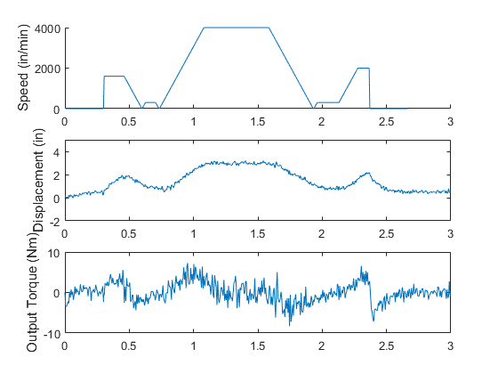

Figure 2 - Simulation of system performance with switching controller

Simulation results show that the torque is within the feasible range. Also, it is clear that the step velocity profile generates very comparable torques to the constant acceleration profile. This shows that the system is balanced properly as one is not significantly more than the other. We can there is no discernable jump in the torque due to switching at around 2 inches of dancer travel which affirms that no Zeno conditions exist that would potentially cause oscillation and subsequent failure.

# Experiment

An experiment was conducted using the same velocity profile shown in Figure 2. The performance was as expected and had less noise than the original simulation. The result is shown in Figure 3.

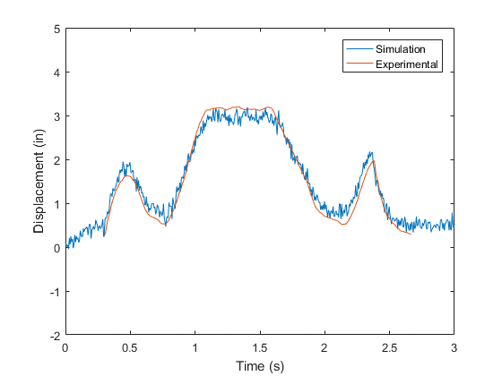

Figure - Comparison between simulation and experiment

As from before, there is acceptable agreement between theory and experiment. It is thus, in principle possible that a PLC using a predictive model can check whether there are errors in the tension control system in real time by comparing dancer travel to predicted behavior. Dancer displacement characteristics in response to feed velocities are independent of spool diameter as long as diameter measurements are accurate which simplifies the implementation immensely. Thus, small or drifting deviation from projected behavior can likely mean sensors must be recalibrated. A real time algorithm using a simple regression check can be used to detect errors in the future.

# Conclusion

Changes in the control structure has helped reduce the likelihood of film material related failures. This combined with a slightly higher overall tension and small adjustments to the film spindle are likely to completely eliminate tangling failures in the future. The control structure behaves closely to predictions which allows for possible real time safety checks to be implemented.